Trajectory Matching Analysis

25 realizations of simulated, stochastic epidemic time-series data was produced using the pomp package with the following parameters: beta_sd = 0.1, Beta=1.5, mu=0.1, gamma=0.6, rho=0.8, N=10000. 38 trajectory matches for Raw and Cumulative data was done for each of the 25 realizations

using a different amount of time points (increment by 1 each time). All trajectory matches were done with starting estimates as follows: beta_sd=0.12, Beta=1.8, mu=0.15, gamma=0.65, rho=0.75, N=10000.

**The 25 raw simulations**

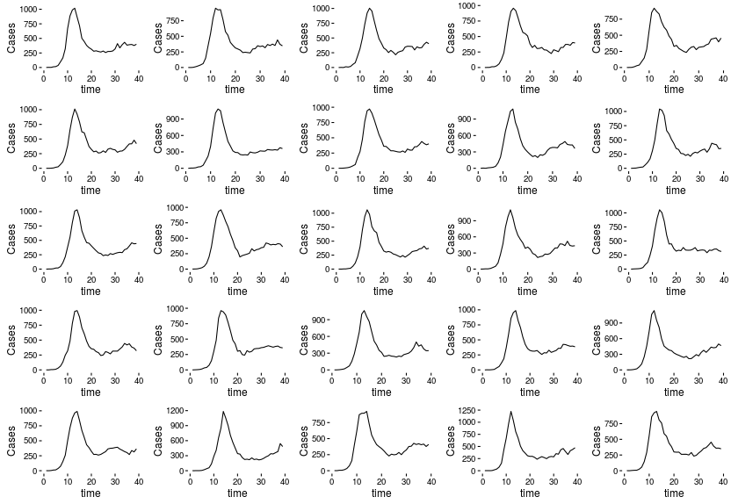

**Raw Traj Match: 2 points** (3 diverged from data and produced errors in graphing (4, 5, and 18))

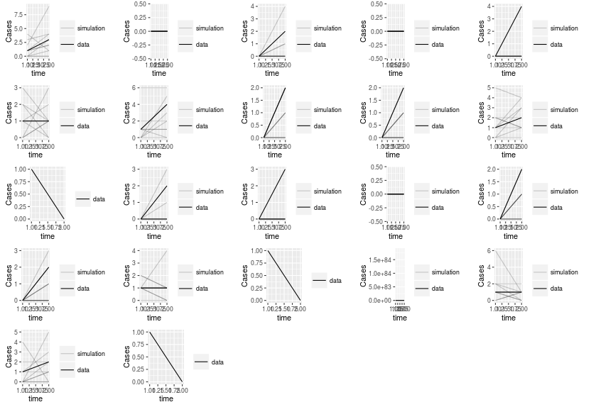Trajectory matching was inconsistent, and often predicted the same result with each of the 10 simulations.

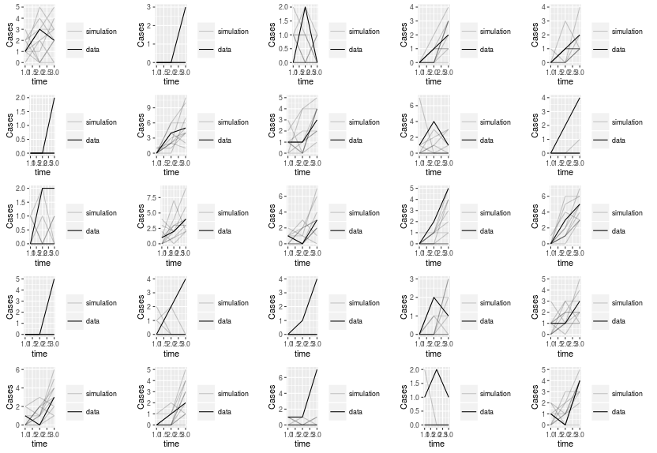**Raw Traj Match: 3 points** (None diverged from data)

Trajectory matching still somewhat inconsistent. Some were pretty good, others not so much. Still appears to be too little data points.

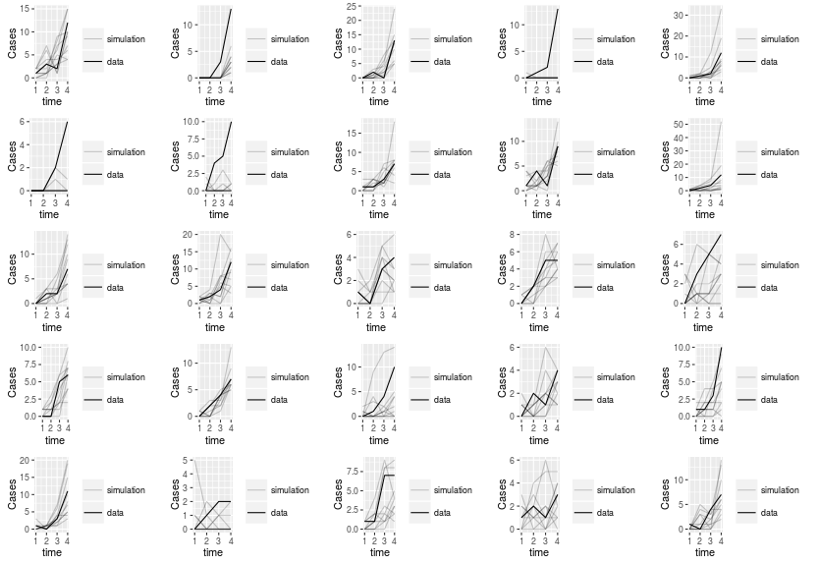**Raw Traj Match: 4 points** (None diverged from data)

Trajectory matches are slightly better. Have some that don't predict the takeoff well (2, 4, 6, 7, 21).

**Raw Traj Match: 5 points** (None diverged from data)

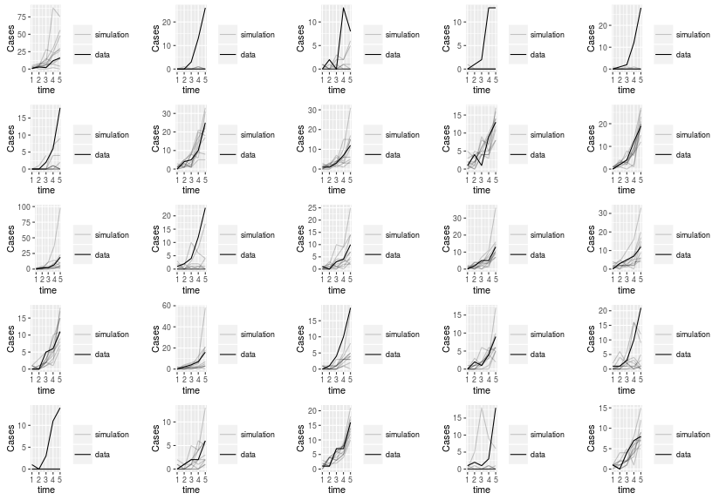Those that match data closely are better with 5 points than 4 points, but those with inaccurate matches (2, 3, 4, 5, 11, 21, 24) are worse than 4 points.

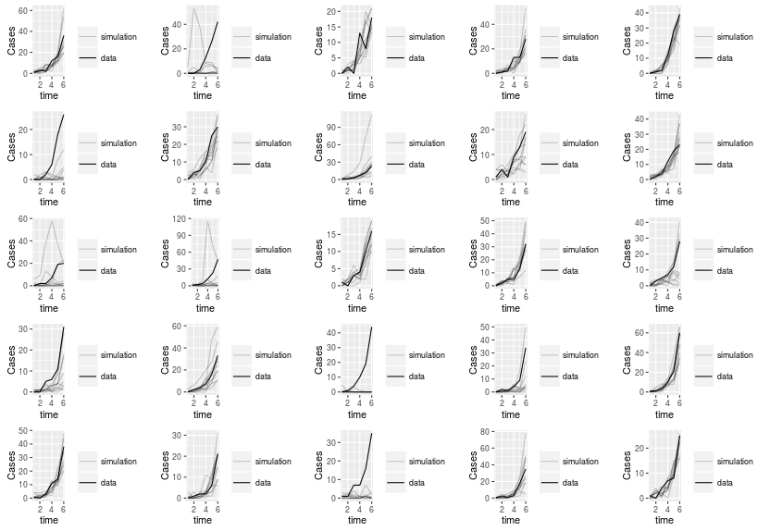**Raw Traj Match: 6 points** (None diverged from data)

Trajectory matches in general are getting better. Not sure what could be the reason why those with poor predictions are failing. It seems like the higher amount of cases seems to be the problem, but in cases like 2 and 5 with about the same takeoff, one traj match is way better.

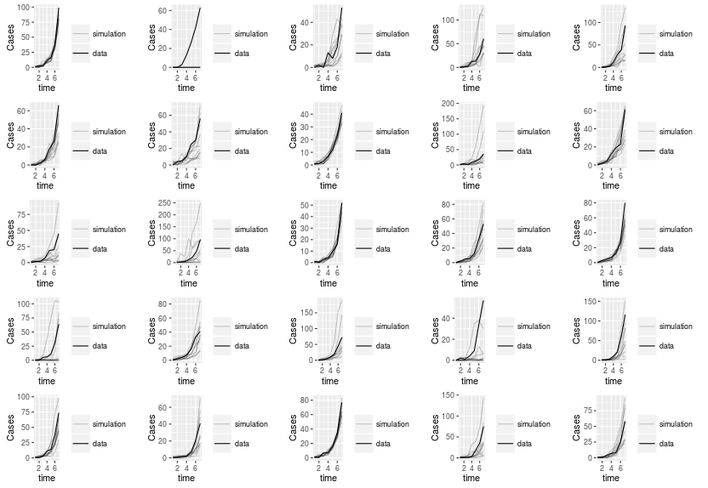**Raw Traj Match: 7 points** (None diverged from data)

Basically three scenarios: over prediction, under prediction, or very close fit to data. None really stand out from these three scenarios.

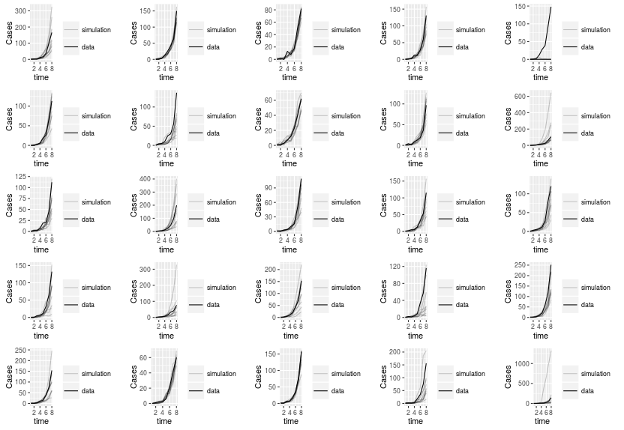**Raw Traj Match: 8 points** (None diverged from data)

Traj matches are doing very well with only 8 points with a few outliers.

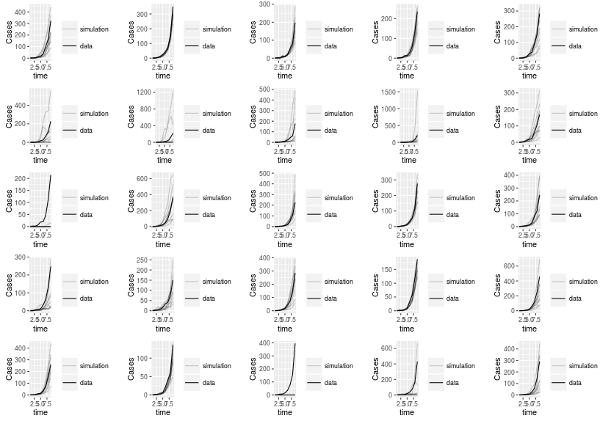**Raw Traj Match: 9 points** (None diverged from data)

More outliers than traj matches with 8 points, but still predicting very well with only a few points.

**Raw Traj Match: 10 points** (None diverged from data)

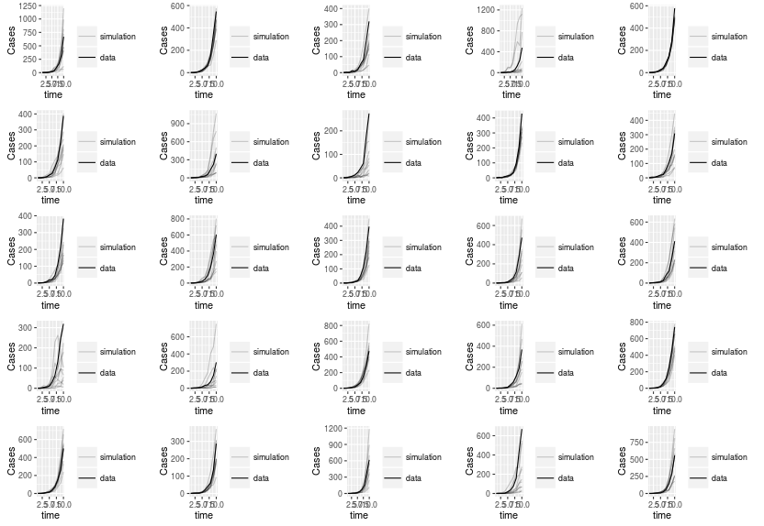

All traj matches do a great job of predicting curve.

**Raw Traj Match: 11 points** (None diverged from data)

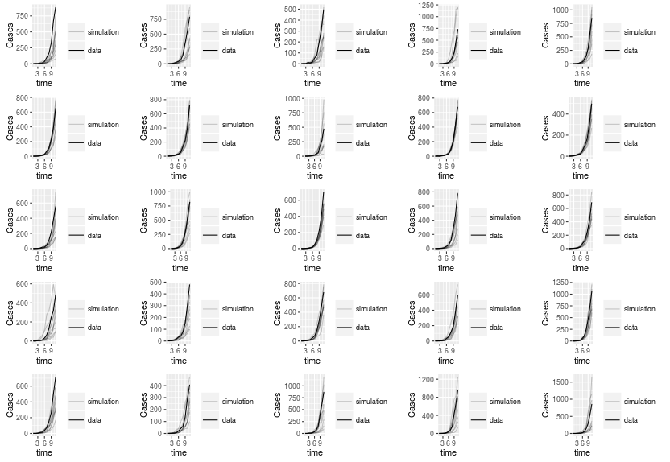Less variability being shown between simulations when points are increasing. Still does a good job predicting takeoff.

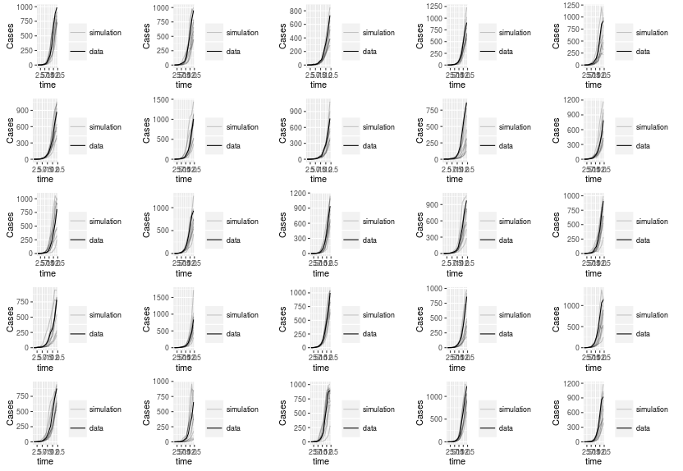**Raw Traj Match: 12 points** (None diverged from data)

As some of the simulations reach peaks, traj matches appears to be doing a good job of taking into account the slowing down of growth at 12 points.

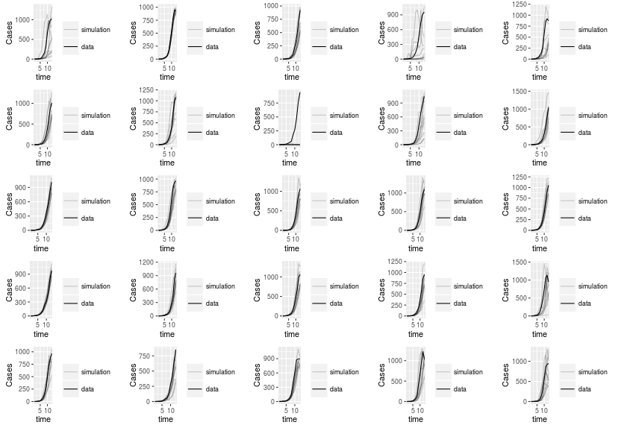**Raw Traj Match: 13 points** (None diverged from data)

More variability with 13 points. One graph (Plot 8) fails to predict trajectory.

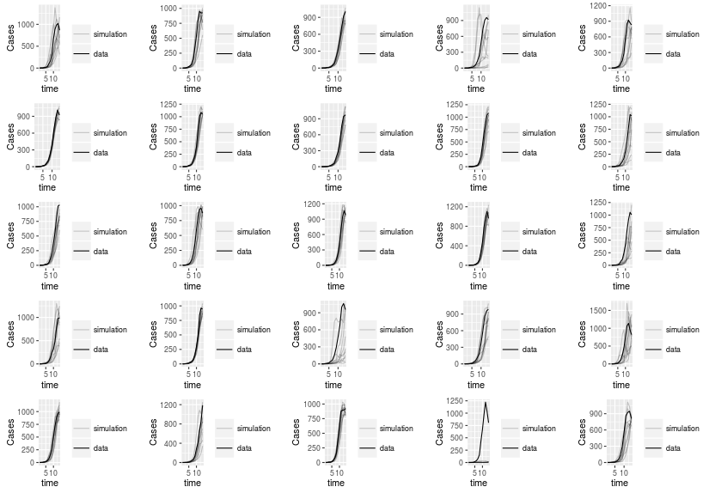**Raw Traj Match: 14 points** (None diverged from data)

Simulations appear to get more stochastic (more uncertainty) as it approaches peak and downfall of epidemic. Plot 24 fails to predict trajectory at 14 points. Maybe because of steep decline?

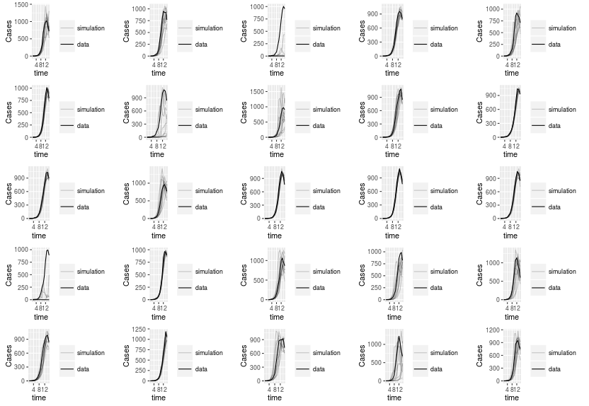**Raw Traj Match: 15 points** (None diverged from data)

At this point, all epidemics have reached peak and began to decline. Some traj matches predicted this well, while others failed(3, 8, 16).

**Raw Traj Match: 16 points** (None diverged from data)

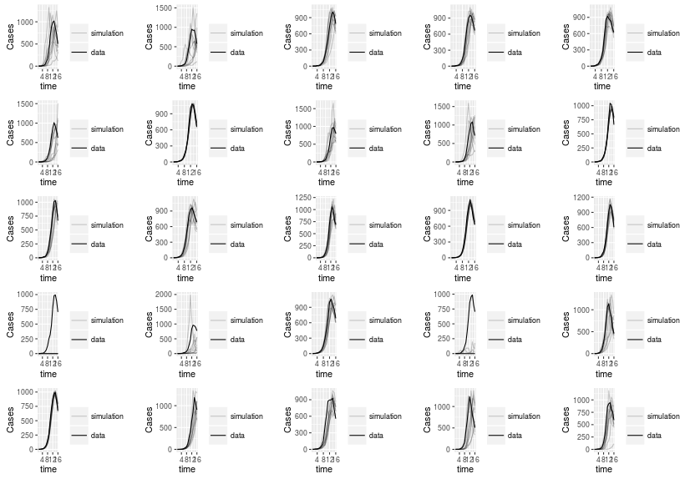With 16 points, you either get very accurate trajectory matches, or some start to really diverge. Plot 16 fails to ever take off when you have 16 points in the graph. Plot 19 has really small growth compared to actual trajectory. Plots 2, 6, and 22 still has some simulations that don't slow down growth.

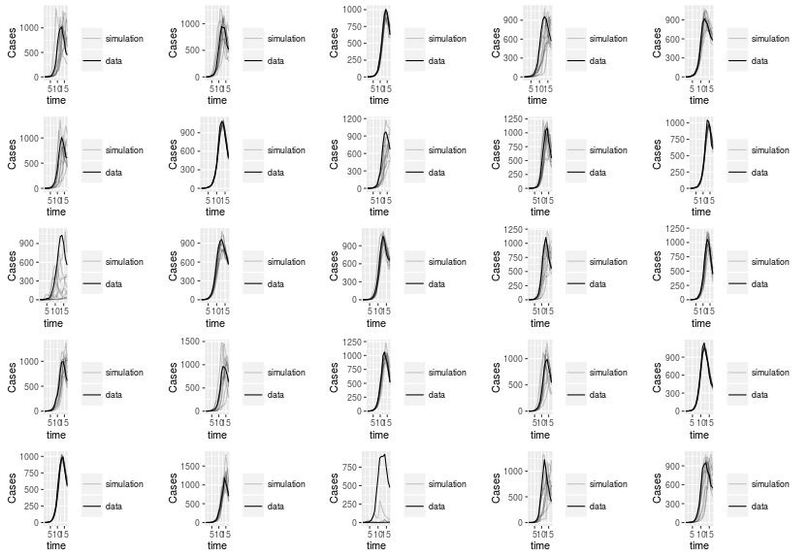**Raw Traj Match: 17 points** (none diverged from data)

With 17 data points, most graphs are now all taking into account the downfall, but plot 23 fails to account for takeoff correctly.

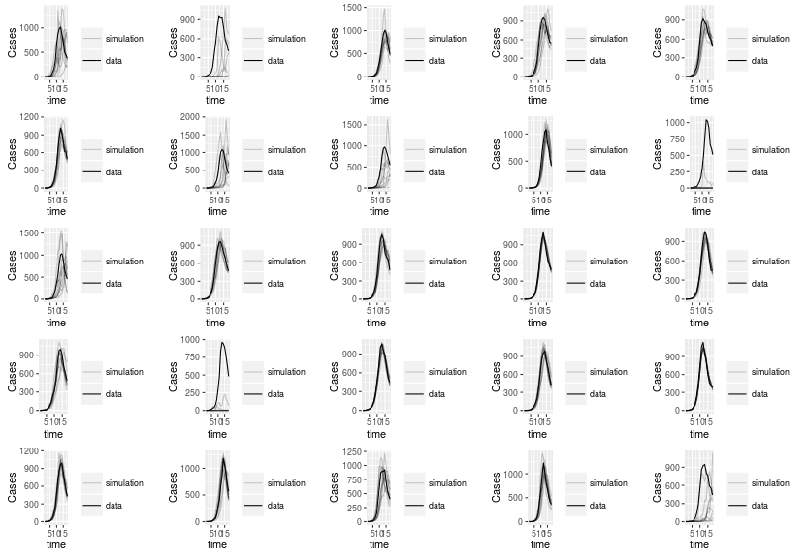**Raw Traj Match: 18 points** (None diverged from data)

At 18 points, you start to see some traj matches not fitting to the data as well (1, 2, 10, 17, 25). But most do very well.

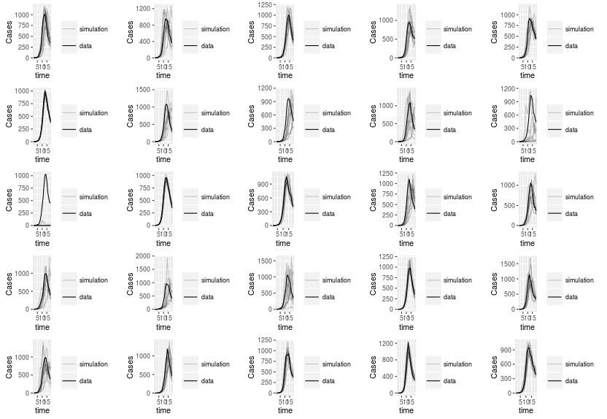**Raw Traj Match: 19 points** (None diverged from data)

At 19 points, most do very well and usually over predict take off, but account well for slow down. Plot 10 has a lot of stochastic noise. Plot 11 fails to match traj. Plot 17 has one outliers.

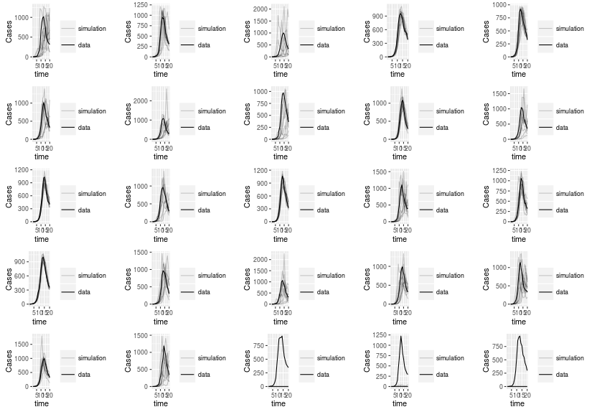**Raw Traj Match: 20 points** (None diverged from data)

Most traj matches are still doing well. Interestingly, plots 23, 24, and 25 all fail to account trajectory at 20 points despite doing well previously.

**Raw Traj Match: 21 points** (None diverged from data)

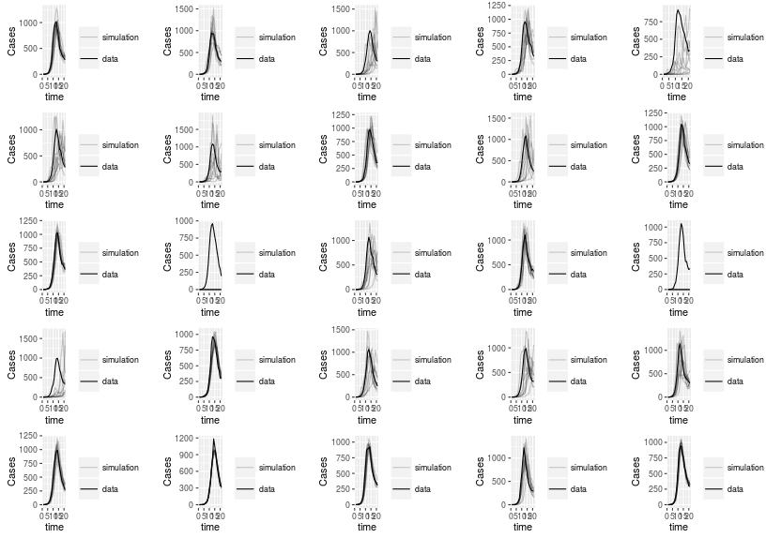Most traj match really well. Plot 3, 5, 6, 7, 9, 19 all have a lot of noise in simulations. Plot 12 and 15 have poor traj matches.

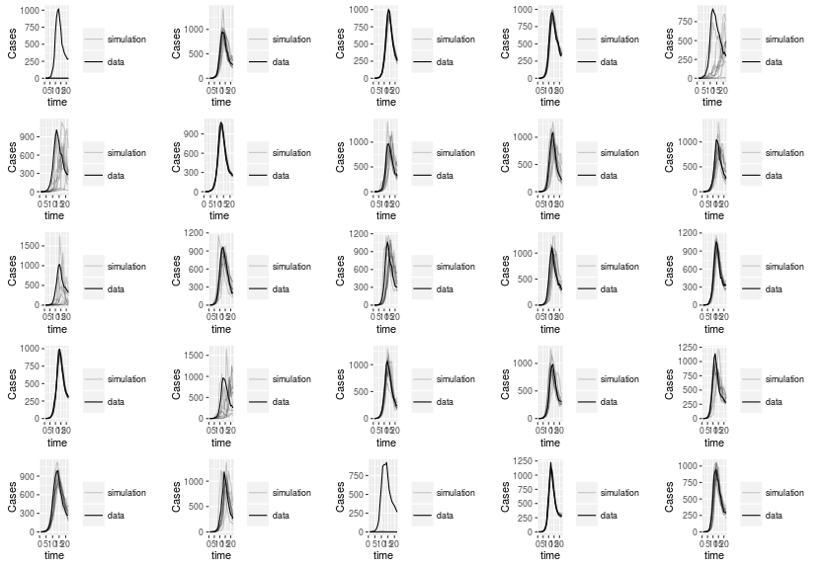**Raw Traj Match: 22 points** (None diverged from data)

Again, most do well. Plot 1 and 23 have failed traj matches. Plots 5, 6, 11, 17 seems to struggle with slow down rate.

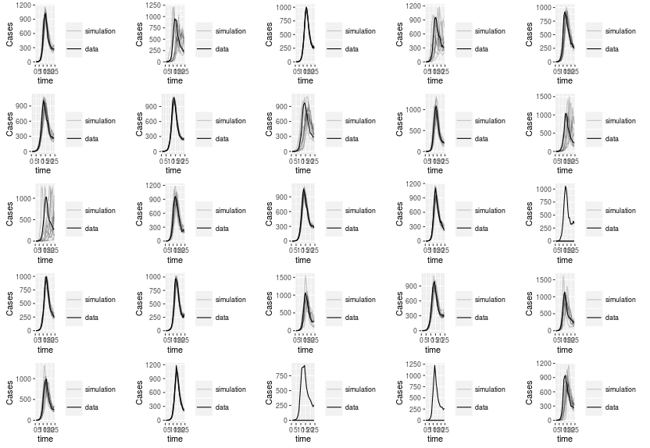**Raw Traj Match: 23 points** (None diverged from data)

3 failed attempts at matching (15, 23, 24). Plot 11 is not slowing down at all.

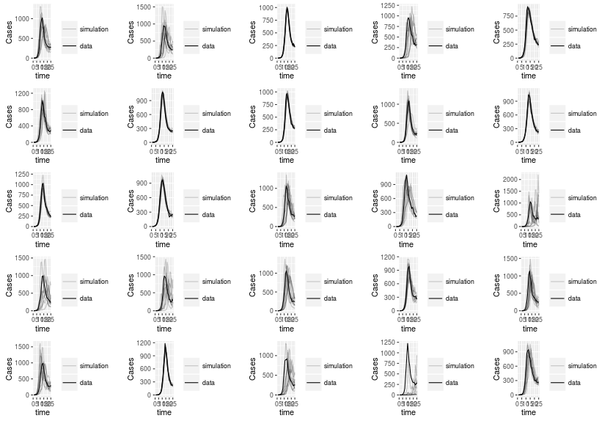**Raw Traj Match: 24 points** (None diverged from data)

Traj matches seems to be struggling now, being less fitted to the data. Likely due to stochastic noise near end of epidemic. Those with failed traj matches with fewer points, really struggle to get back on track (23 and 24).

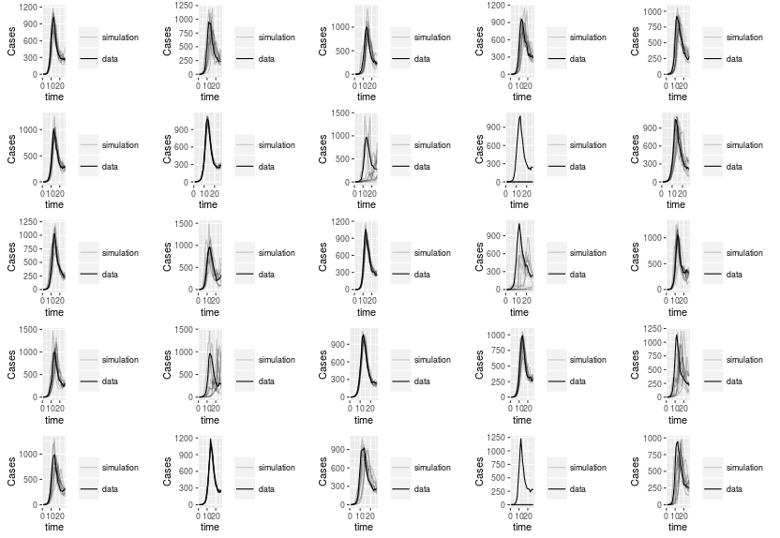**Raw Traj Match: 25 points (**None diverged from data)

At 25 points, they all traj match well, except for 9 and 24.

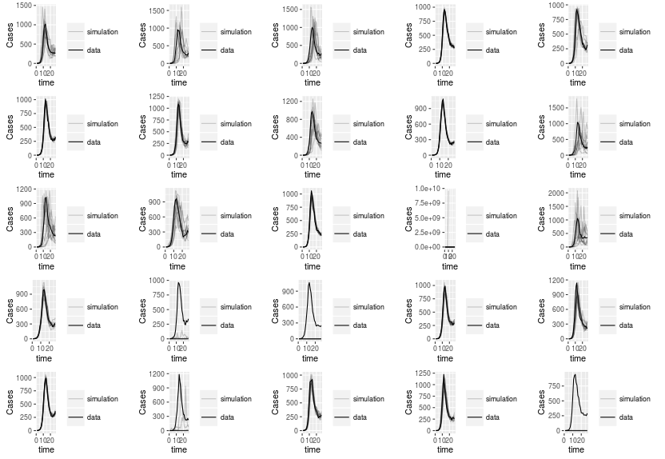**Raw Traj Match: 26 points (**None diverged from data)

At 26 pionts, all match fairly well. Plot 14 predicts crazy growth with one simulation. Plot 17 has very under predicted growth.

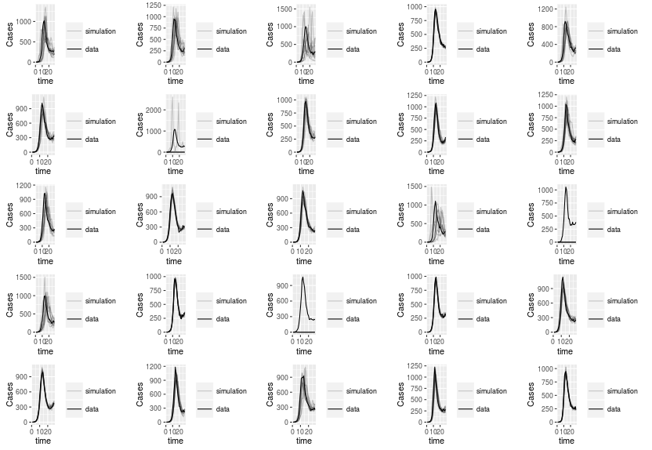**Raw Traj Match: 27 points** (None diverged from data)

Effects of noise are becoming harder to predict with increasing amount of points.

**Raw Traj Match: 28 points** (None diverged from data)

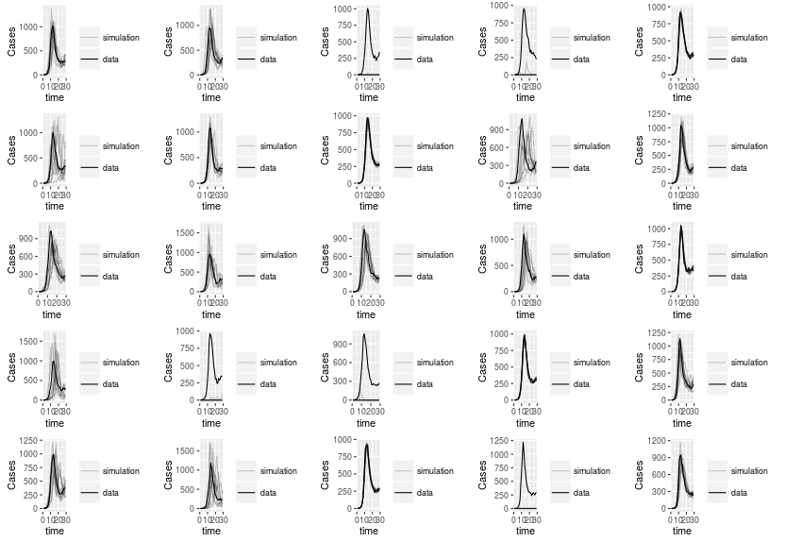Those that actually fit to data well, are really accurate for the most part except for 6 and 9 with a lot of noise. Those that fail to fit data are really awful predictors.

**Raw Traj Match: 29 points** (None diverged from data)

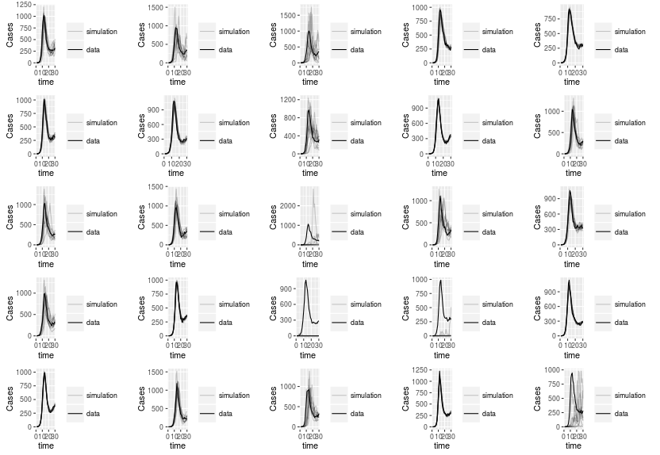Stochastic effects really coming into effect with increasing points. Only a few matches reallyl fitting data well.

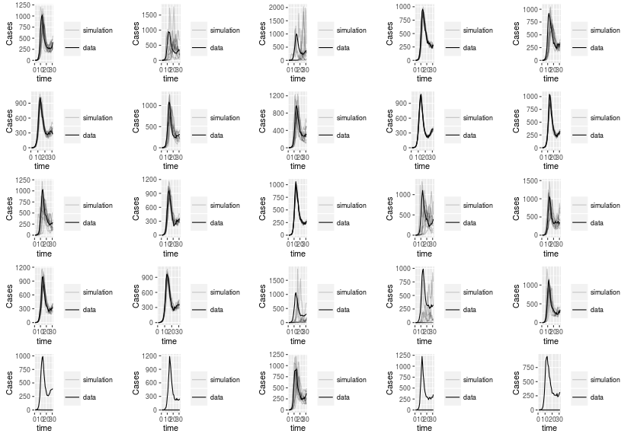**Raw Traj Match: 30 points** (None diverged from data)

At 30 points, see a big increase in failed traj matches (20. 21, 24, 25). Also see some are becoming less and less fitted to the data (2, 3, 14, 15, 18, 19).

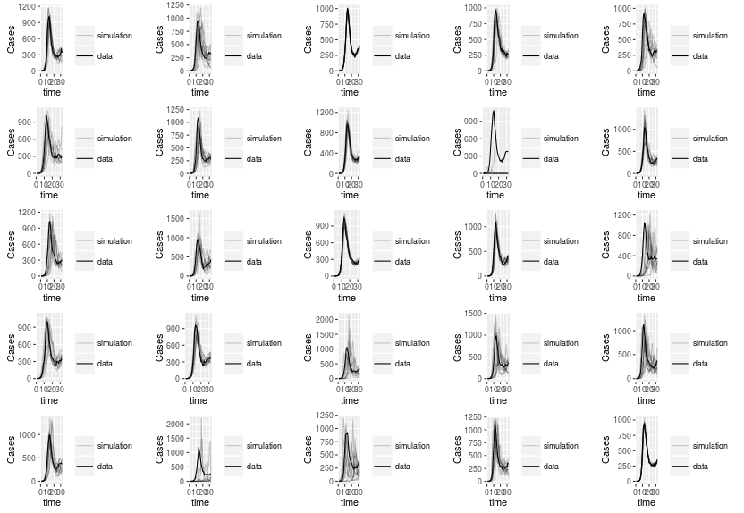**Raw Traj Match: 31 points** (None diverged from data)

In contrast to 30 points, 31 points seems to match fairlyl well with all plots.

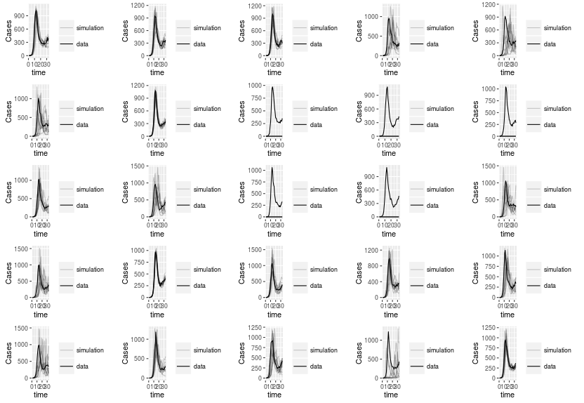**Raw Traj Match: 32 points** (None diverged from data)

Inconsistent with 31 points, there are 5 failed traj matches (8, 9, 10, 13, 14).

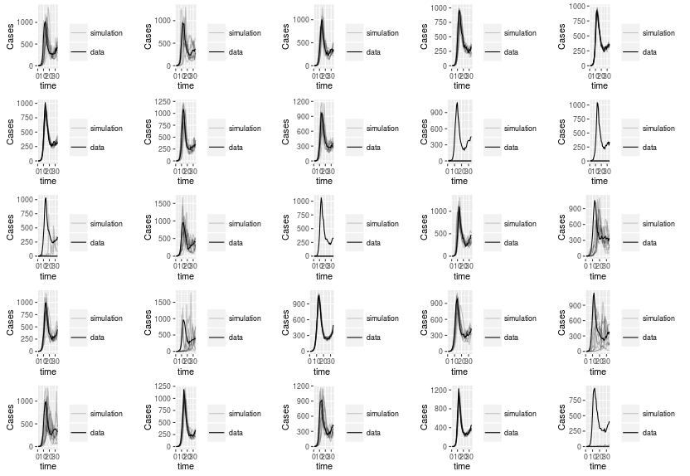**Raw Traj Match: 33 points** (None diverged from data)

Again there are four failed traj matches (9, 10, 13, 25). Traj matches become more noisy with increasing points.

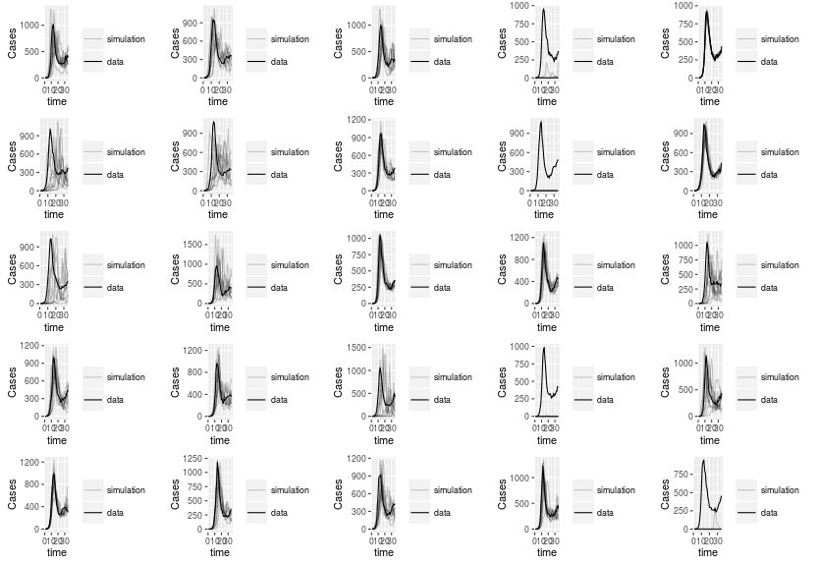**Raw Traj Match: 34 points** (None diverged from data)

again a display of increasing noise with increased amount of points. Have some under predictions with 4 and 25.

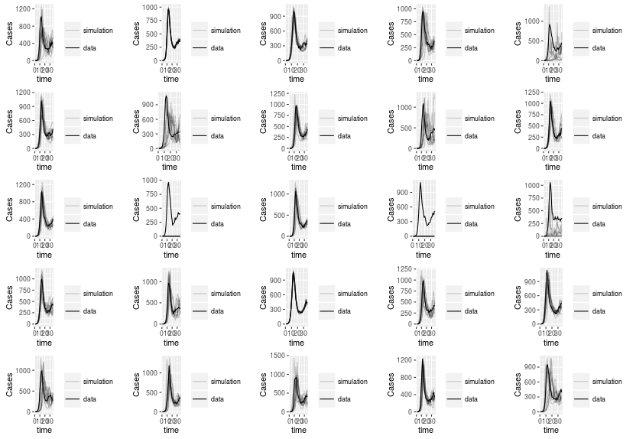**Raw Traj Match: 35 points** (None diverged from data)

Most predicting well. Question: why does increasing points vary data so much for some graphs?

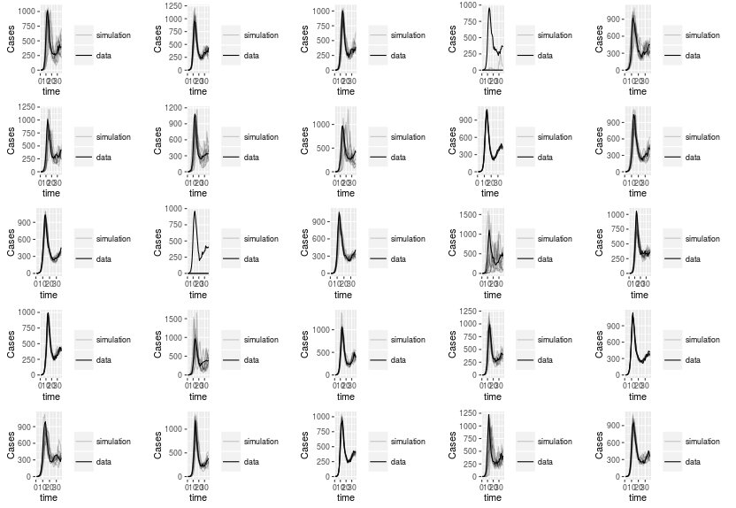**Raw Traj Match: 36 points** (None diverged from data)

With almost all time-series data, most are matching well, but still have some problem graphs (4, 12).

**Raw Traj Match: 37 points** (None diverged from data)

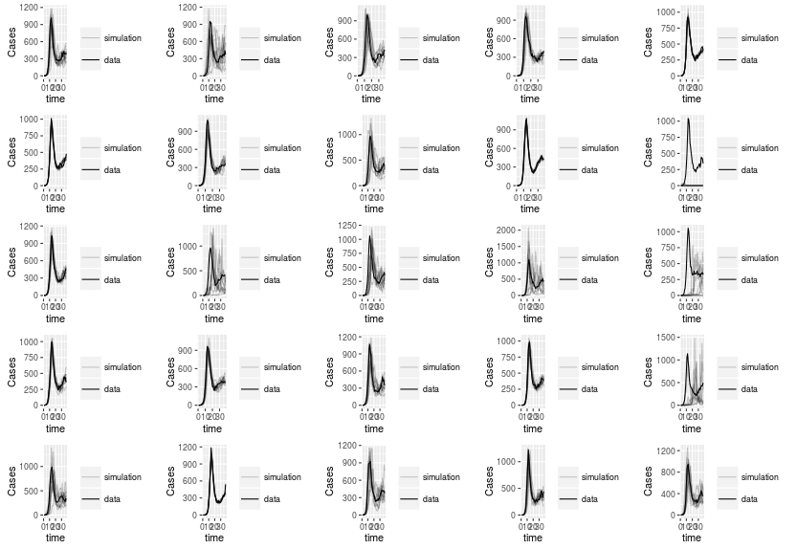Lot of noise near end of the process. Some really slow to takeoff or slow down.

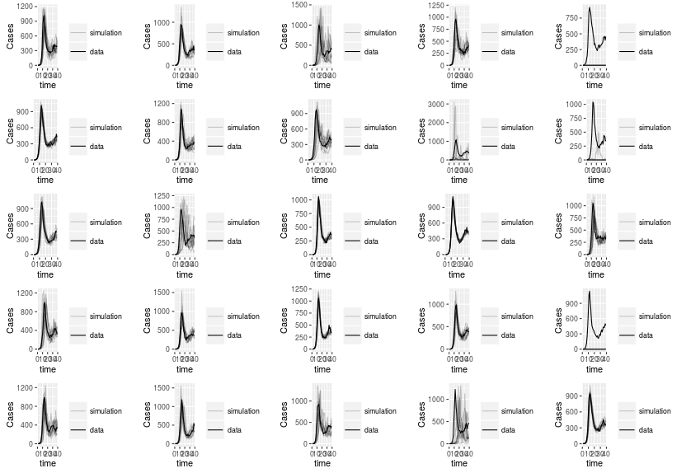**Raw Traj Match: 38 points** (None diverged from data)

With all the data points, trajectory matching does fairly well with with fitting curves to data. However, there is a lot of varying results, and should be weary to be confident in results.

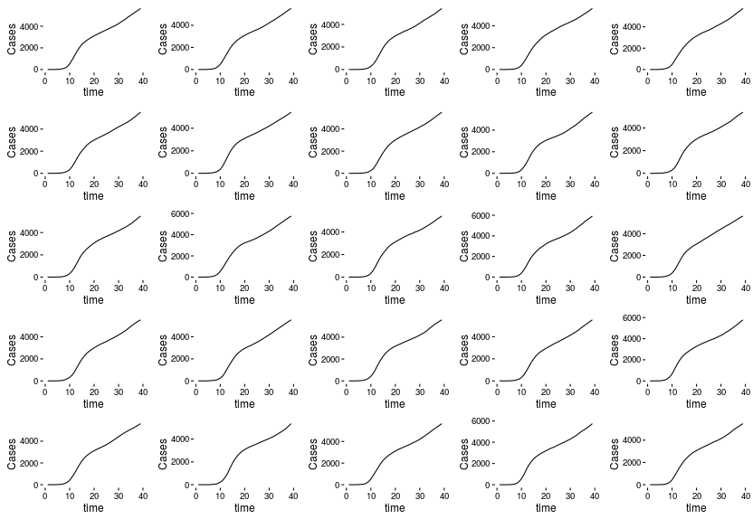**The 25 Cumulative Simulations**

**Cumulative Traj Match: 2 points** (2 diverged from data)

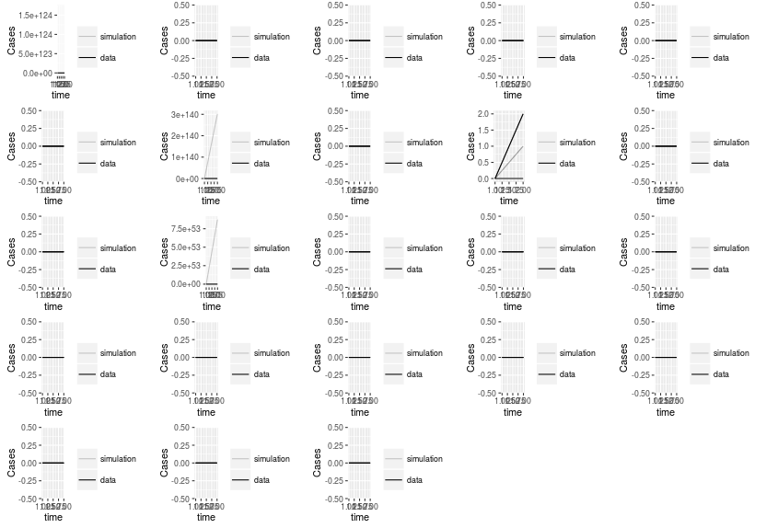One point doesn't give much insight with cumulative data.

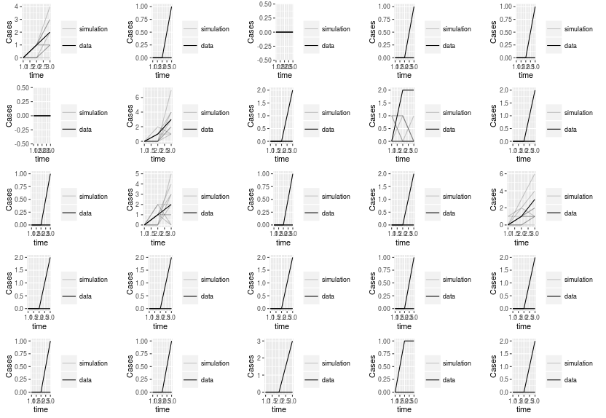**Cumulative Traj Match: 3 points** (None diverged from data)

At 2 points, the trajectory match with cumulative data shows inconsistent results with how successful simulations are fit to the data. Still seems to be too early for traj matching to be useful.

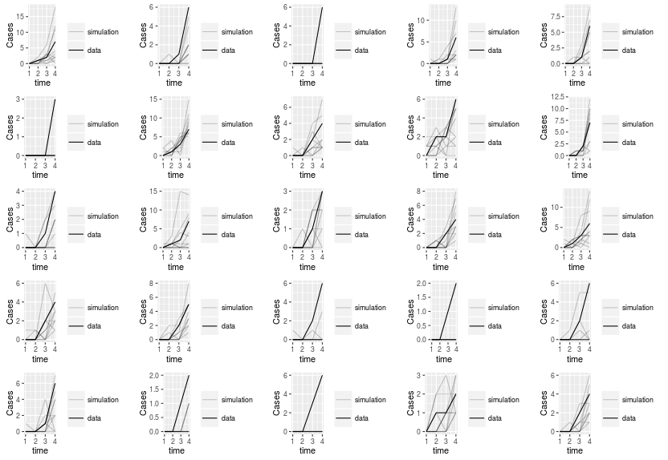**Cumulative Traj Match: 4 points** (None diverged from data)

At 4 points, most traj matches are now actually predicting a takeoff with the epidemic. However, only a few are actually fit well with the data.

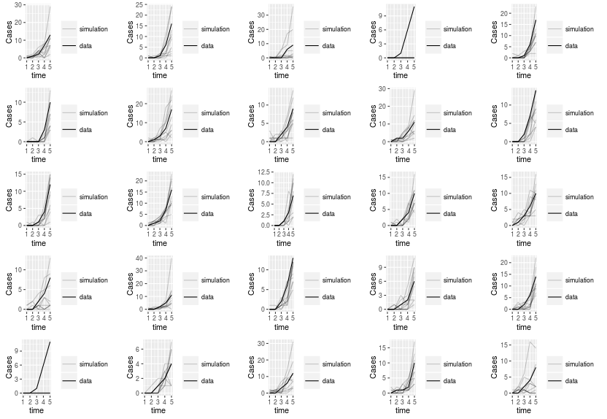**Cumulative Traj Match: 5 points** (None diverged from data)

Traj matches are now actually fitting well to the data in most cases. Plot 4 and 21 have failed traj matches.

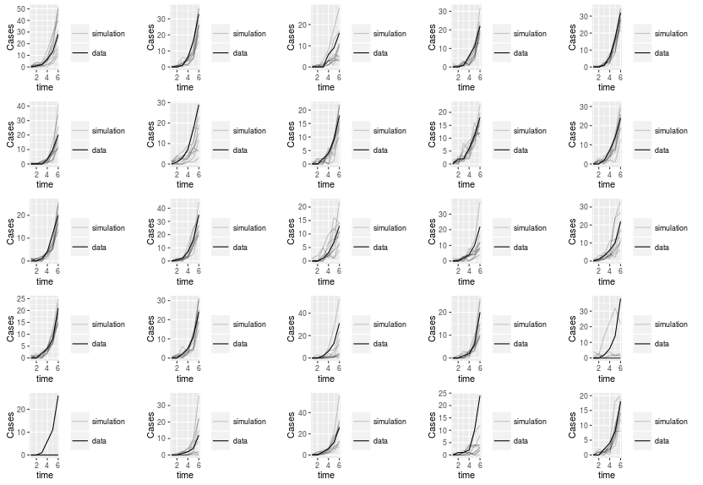**Cumulative Traj Match: 6 points** (None diverged from data)

With 6 points, we see similar results to that of 5 points. Most traj matches fit well. 21 still is failing to get an accurate traj match. Smoothing effect of cumulative counts seems to be taking place.

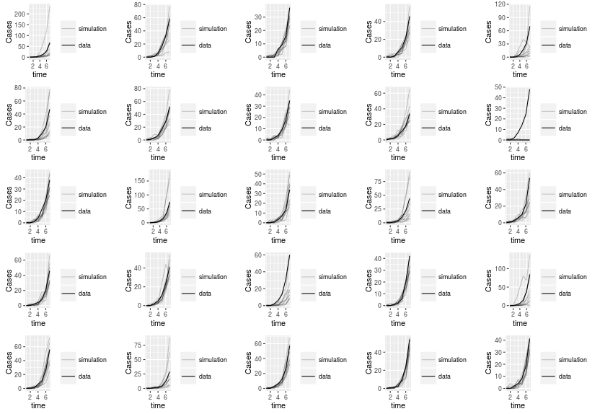**Cumulative Traj Match: 7 points**

Again it can be seen that most traj matches appear to fit well to the data.

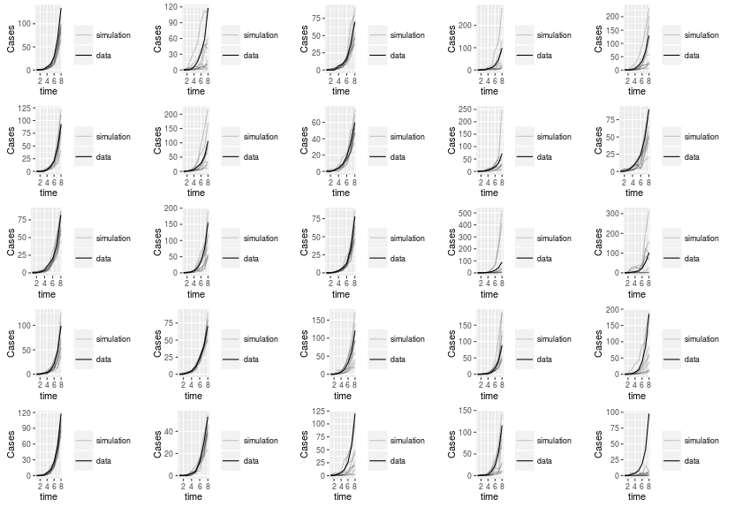**Cumulative Traj Match: 8 points** (None diverged from data)

As epidemic continues to takeoff, trajectory matching still doing well at fitting to actual data likely due to the smoothing effect of cumulative counts. Probably still not quantifying uncertainty as pointed out in Pej's paper.

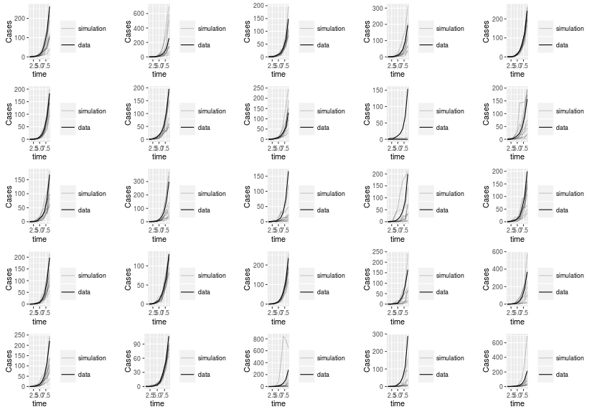**Cumulative Traj Match: 9 points** (None diverged from data)

Still predicting takeoff well.

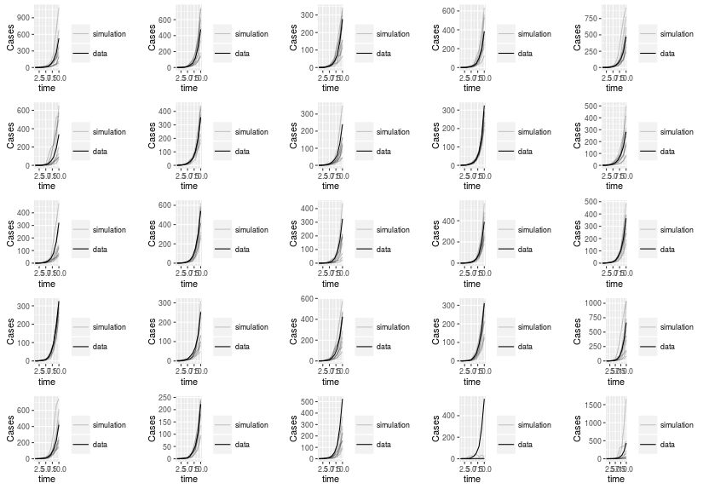**Cumulative Traj Match: 10 points** (None diverged from data)

While most are still predicting well, plot 24 fails to account for takeoff with 10 points. Plot 25 also seems to over predict it.

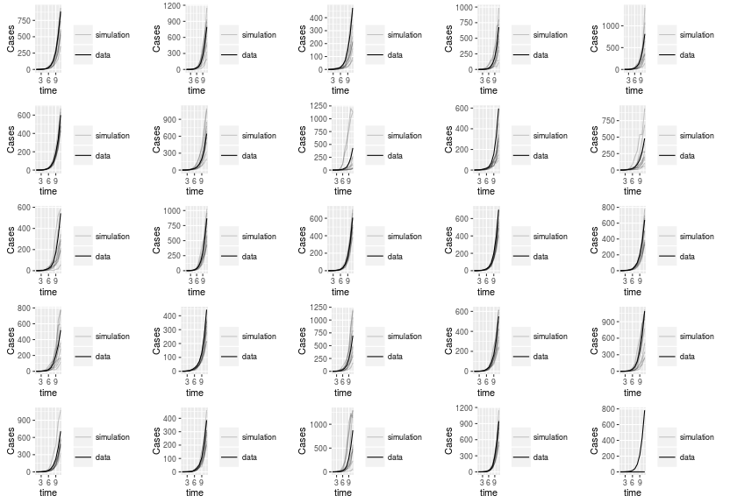**Cumulative Traj Match: 11 points** (None diverged from data)

Starting to see less precision with fitting to the data at 11 points. General trend of trajectories are still accurate though. Plot 25 now has a failed traj match.

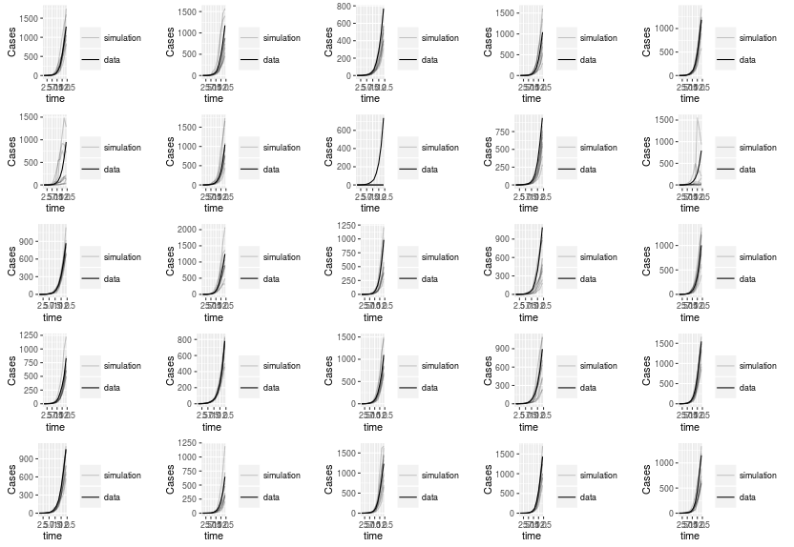**Cumulative Traj Match: 12 points** (None diverged from data)

Plot 8 has failed traj match. Most are starting to slow down their takeoff, as consistent with the data.

**Cumulative Traj Match: 13 points** (None diverged from data)

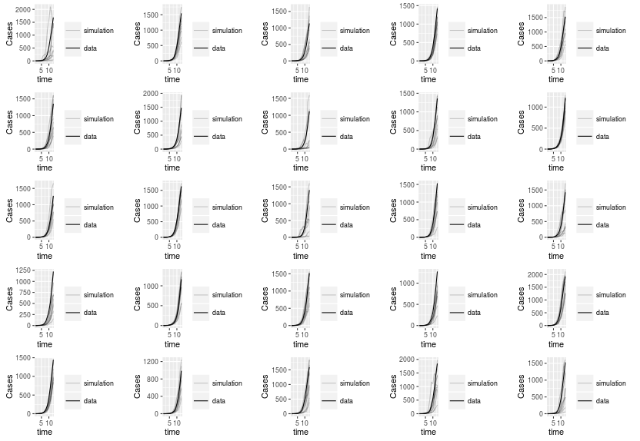All traj matches are fit incredibly well to the data, but this is part of problem pointed out in earlier paper about not accurately quantifying uncertainty. Illusion of high precision.

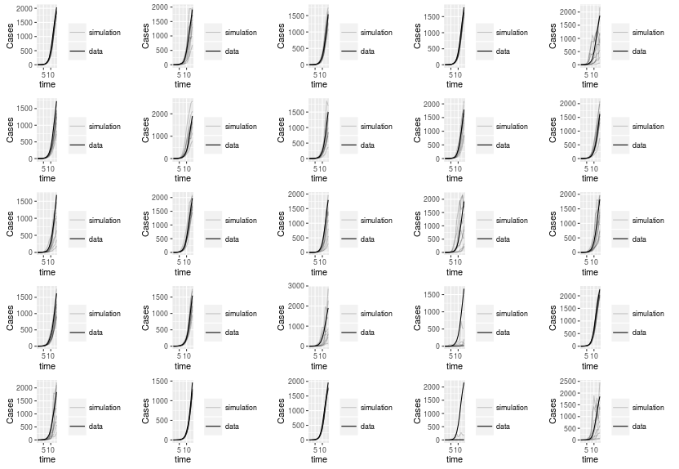**Cumulative Traj Match: 14 points** (None diverged from data)

Same interpretation from 13 point traj matches. 24 again fails to have simulations predict the takeoff in an accurate way.

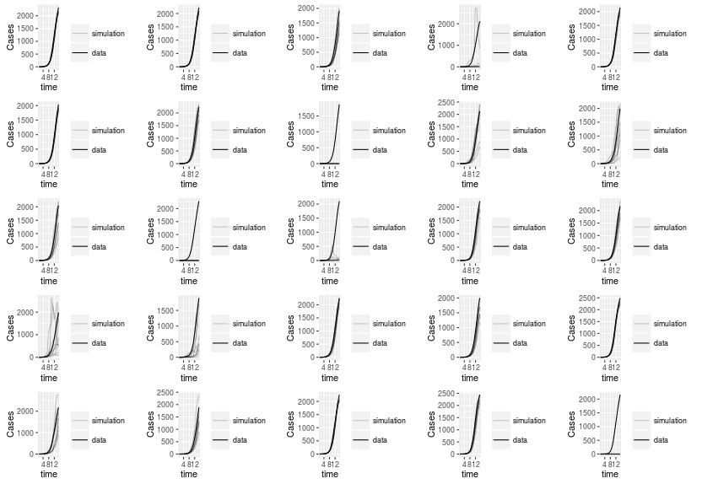**Cumulative Traj Match: 15 points** (None diverged from data)

At 15 points, starting to see either very good fits (1, 2, 3, 5, 7, 21, etc.) or very poor/failed fits(4, 8, 12, 13, 16, 25).

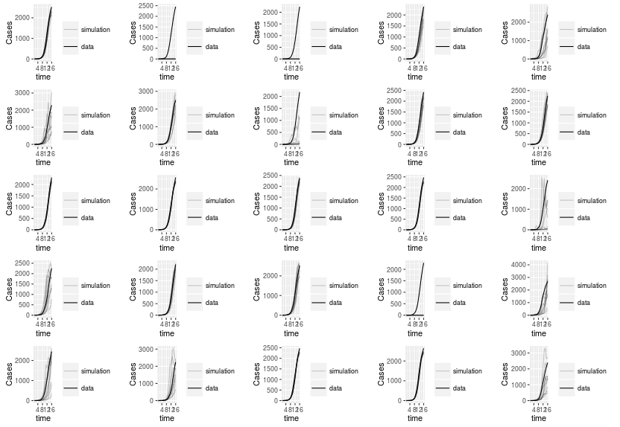**Cumulative Traj Match: 16 points** (None diverged from data)

Still a lot of fits failing to fit with traj match (2, 3, 19). Some seem like they're not slowing down as quickly as the data (5, 6, 15, 16, 22, 25).

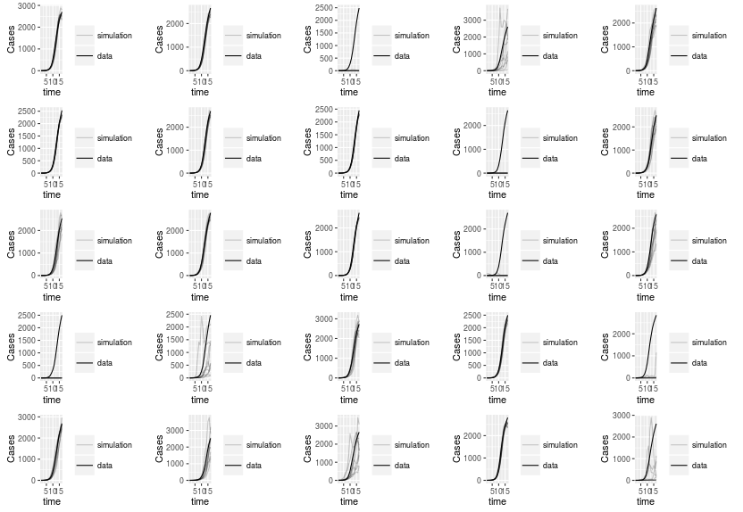**Cumulative Traj Match: 17 points** (None diverged from data)

Starting to see a lot of variation in the graphs that don't fit data well. For example, 3, 9, 14, 16 have “failed” matches. 4, 17, and 25 seem to over predict. 20 under predicts.

**Cumulative Traj Match: 18 points** (None diverged from data)

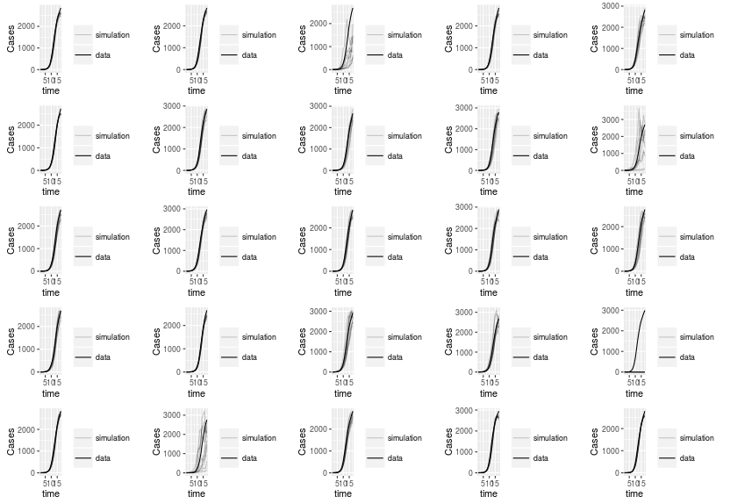Most data fits well at 18 points, which is slightly after point of inflection. Still have a few (3, 10, and 22) that seem slow to account for slow down. Still have some failed matches as well (20).

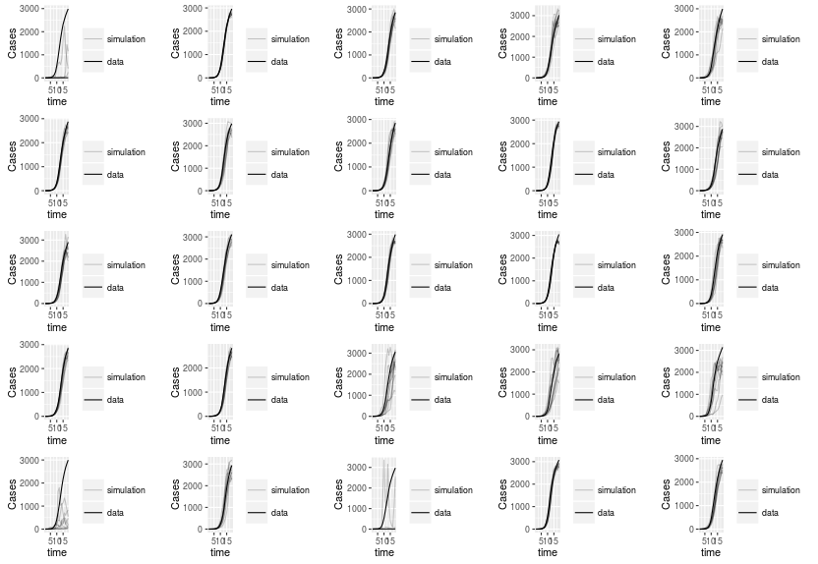**Cumulative Traj Match: 19 points** (None diverged from data)

No failed matches. Most fit really well. Only a few with some variation (1, 20, 21, 23).

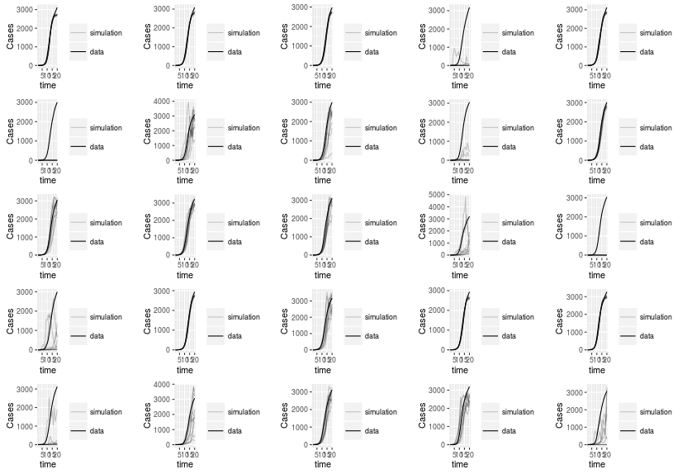**Cumulative Traj Match: 20 points** (None diverged from data)

As most of the simulations start to slow down heavily, see a lot of traj matches start to struggle to account for that in a variety of ways, mostly under predicting (4, 5, 6, 9, 14, 16, 21, 25).

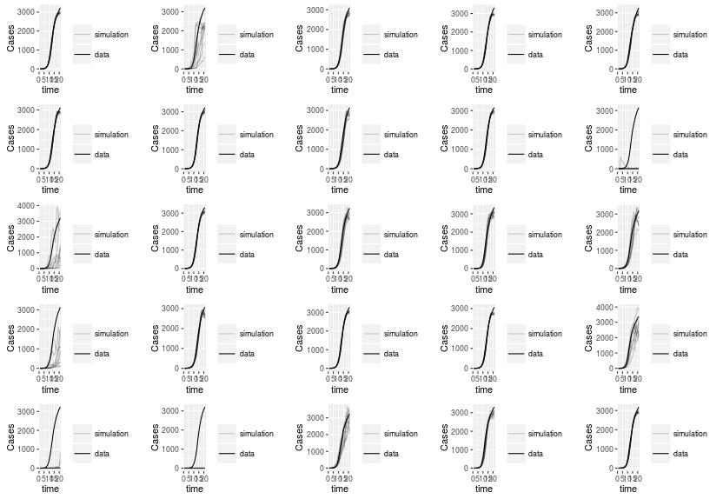**Cumulative Traj Match: 21 points** (None diverged from data)

Most still fitting pretty well. Inconsistencies in fits still apparent though as some really have a lot of stochasticity and others don't.

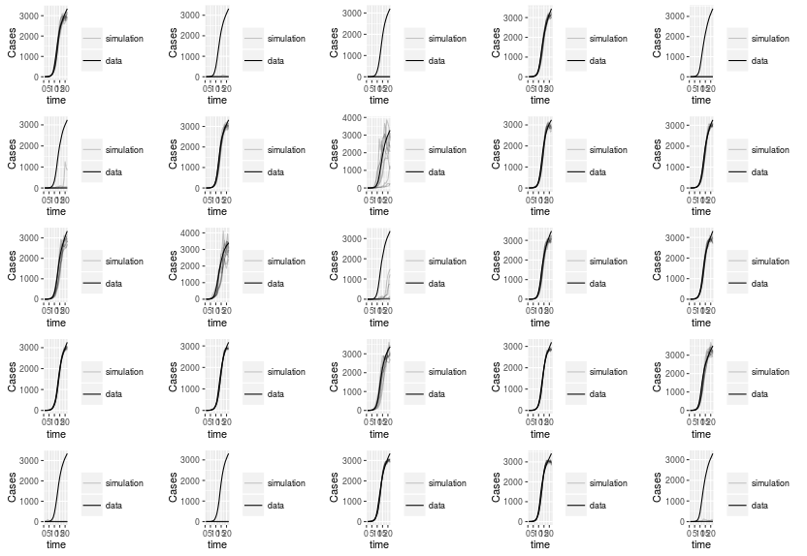**Cumulative Traj Match: 22 points** (None diverged from data)

Have a lot of failed matches at 22 points (2, 3, 5, 6, 13, 21, 22, 25). Yet some still match well. What would be causing this inconsistency?

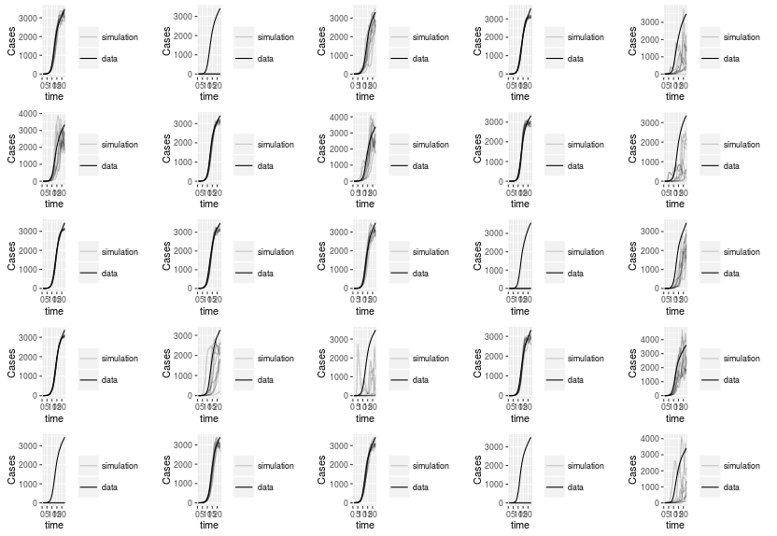**Cumulative Traj Match: 23 points** (None diverged from data)

Simulations really start to get stochastic noisy effects here as they no longer all follow very similar trajectories. Still have some failed matches as well (2, 14, 21, 24).

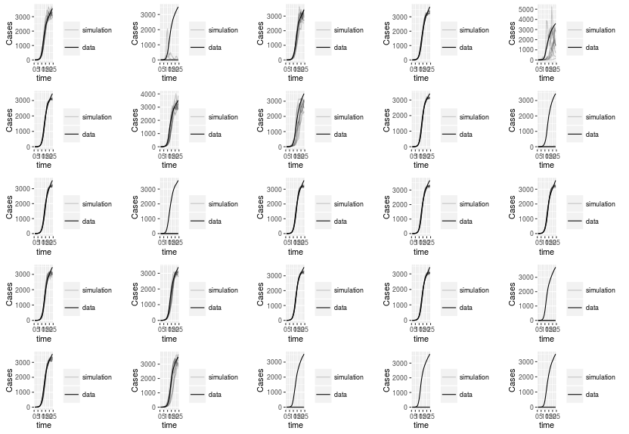**Cumulative Traj Match: 24 points** (None diverged from data)

Loss of noise in a lot of cases here. More failed matches. (10, 12, 23, 24, 25).

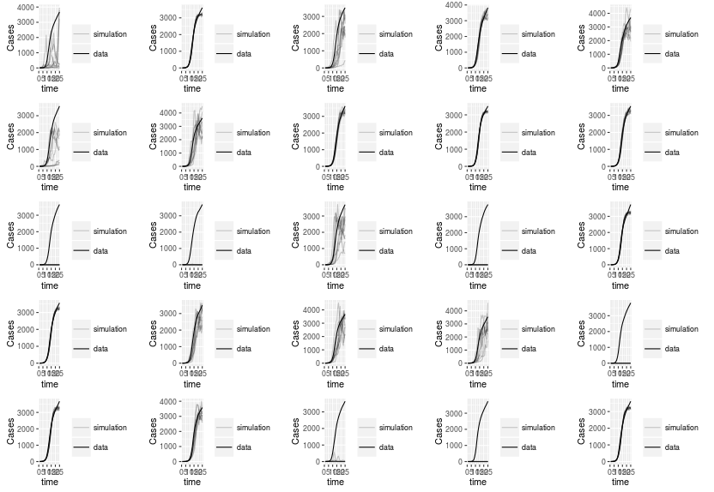**Cumulative traj Match: 25 points** (None diverged from data)

Stochastic noise returns at this point. Why was it lost in the last time stamp? Still have a lot of failed cases (11, 12, 14, 20, 23, 24).

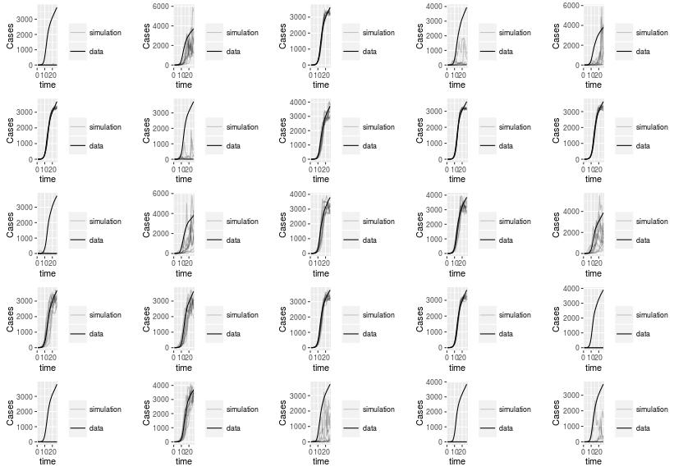**Cumulative Traj Match: 26 points** (None diverged from data)

The more the epidemic slows down, the worse the trajectory matches get. Not sure it is accounting for loss of susceptibles well in the match for cumulative cases.

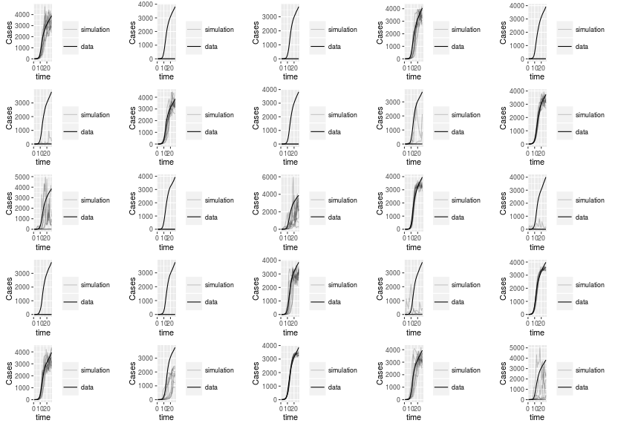**Cumulative Traj Match: 27 points** (None diverged from data)

Again seeing a lot of failed cases (2, 3, 5, 6, 8, 12, 15, 16, 17). The remaining that don't fail aren't showing the same curve as the data.

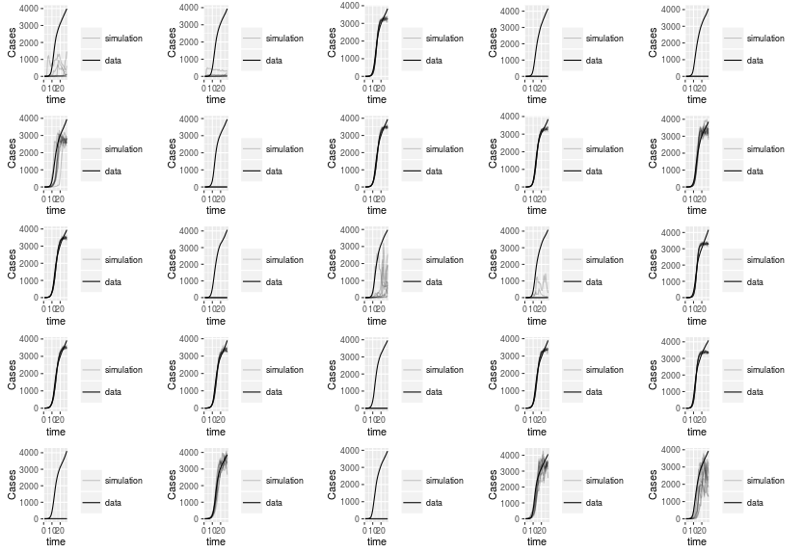**Cumulative traj Match: 28 points** (None diverged from data)

Even more failed cases this time (2, 4, 5, 7, 12, 18, 21, 23). Some matches do well, and others still aren't really following the trajectory of the data curve. Fitting data to cumulative still seems more challenging over course of epidemic.

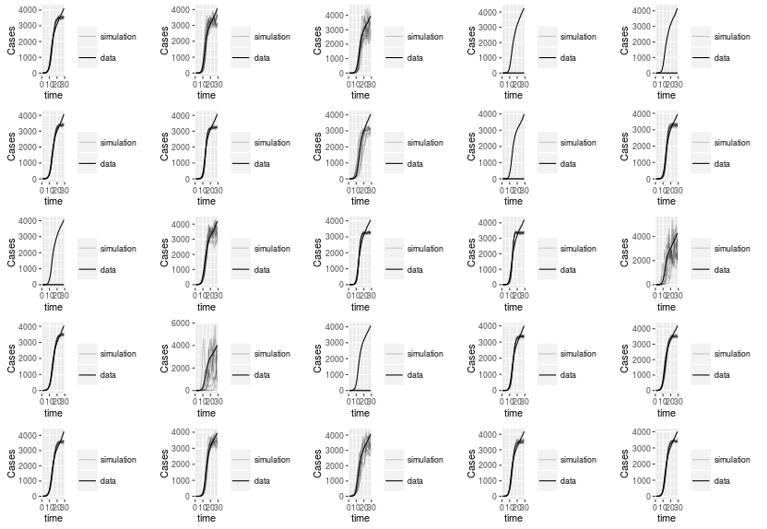**Cumulative Traj Match: 29 points** (None diverged from data)

Still a lot of failed matches (4, 5, 9, 11, 18). Lot of stochastic noise in some trajectories.

**Cumulative traj match: 30 points** (None diverged from data)

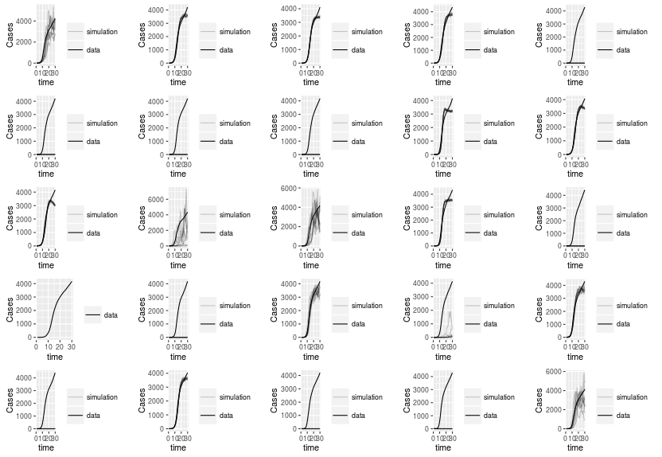Really poor matches here with cumulative data. Lots of failed matches (5, 6, 7, 8, 15, 16, 17, 21, 23, 24). Even those that don't fail struggle to fit to data well (1, 12, 13, 19, 25).

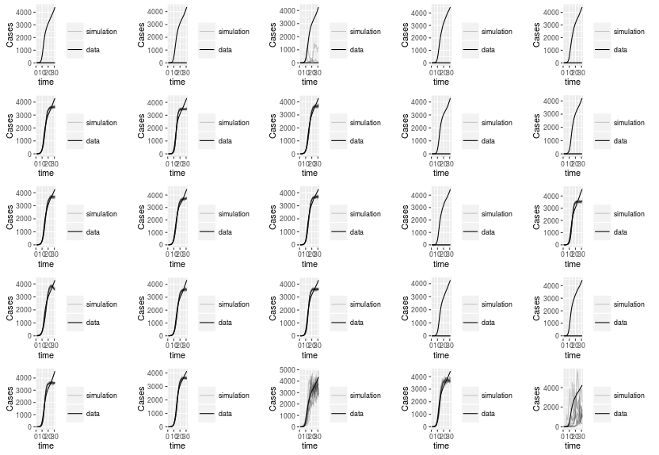**Cumulative Traj Match: 31 points** (None diverged from data)

Still lots of failed matches (1, 2, 4, 5, 9, 20, 14, 19, 20). Simulations slow down faster than actual data dos now, which would be more typical, expected behavior in a system.

**Cumulative Traj Match: 32 points** (None diverged from data)

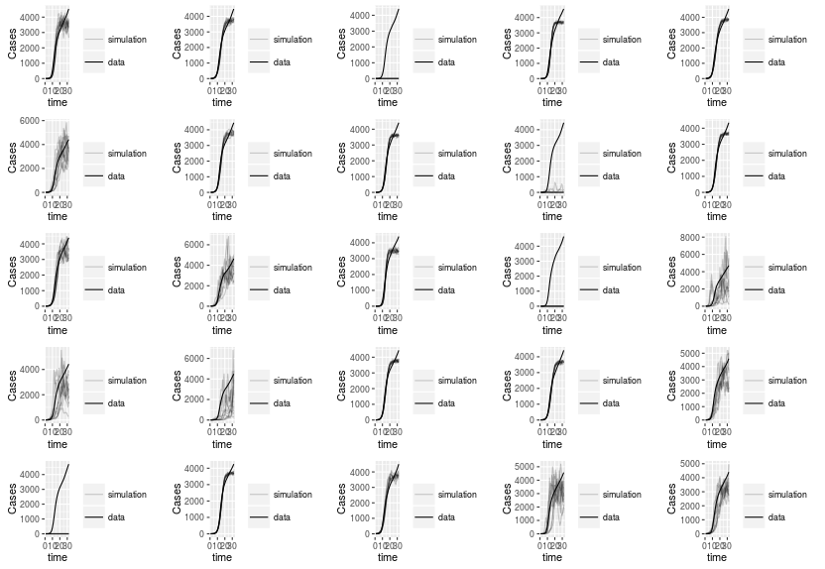At 32 points, really displays how inconsistent the matches can be with some being noisy, some failing, and some slowing down faster than the actual data.

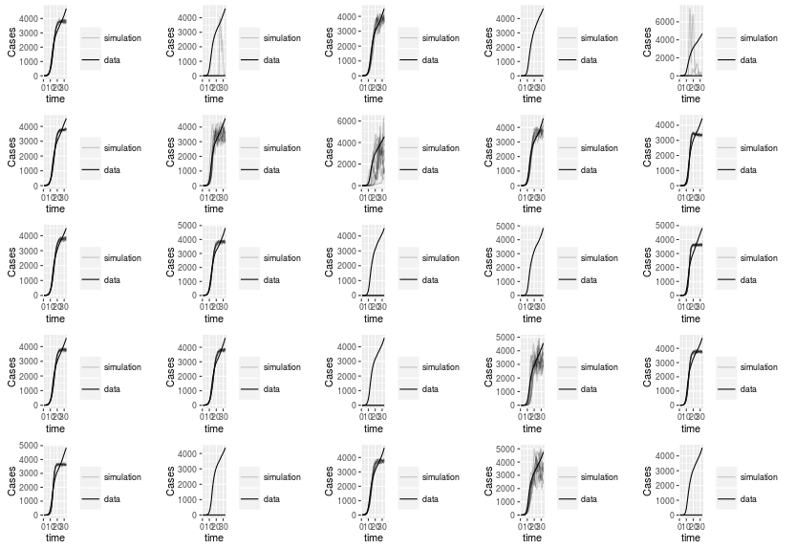**Cumulative Traj Match: 33 points** (None diverged from data)

All of these traj matches are pretty poor. None fit data really well.

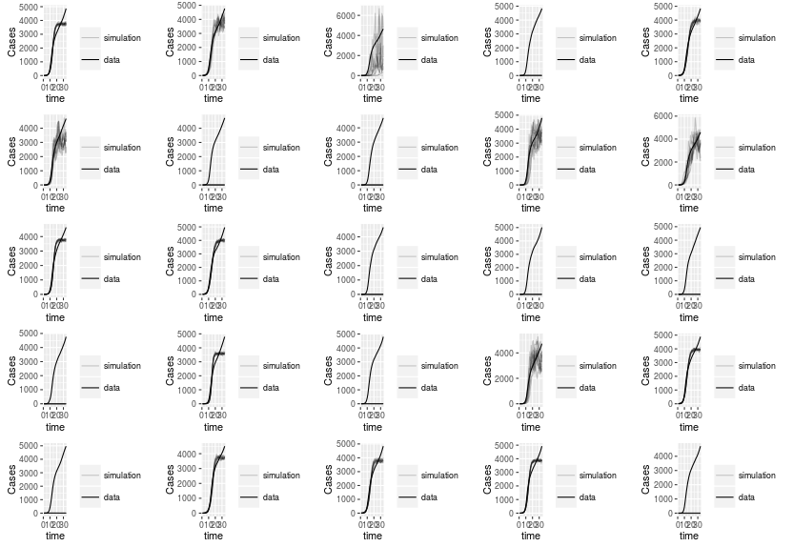**Cumulative Traj Match: 34 points** (None diverged from data)

With increased amount of points, get less accurate traj matches with more failing.

**Cumulative Traj Match: 35 points** (None diverged from data)

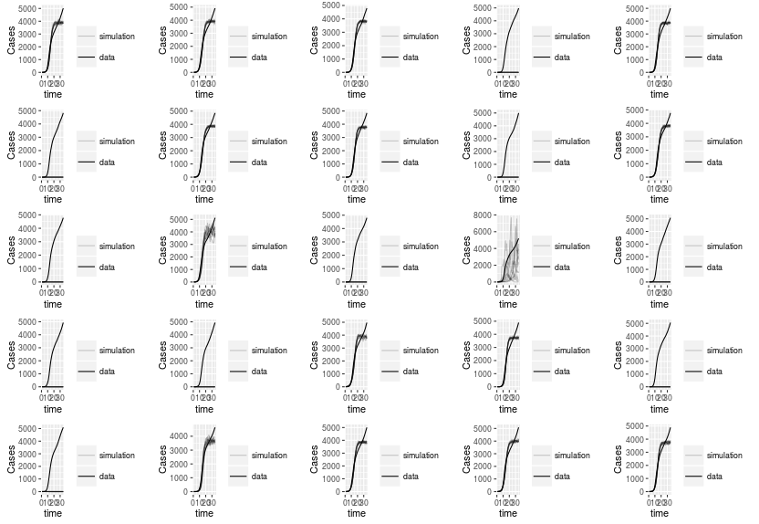10 of the 25 traj matches fail in simulations. Those that don't fail have little success as they are still slowing down at a faster rate than the actual epidemic does.

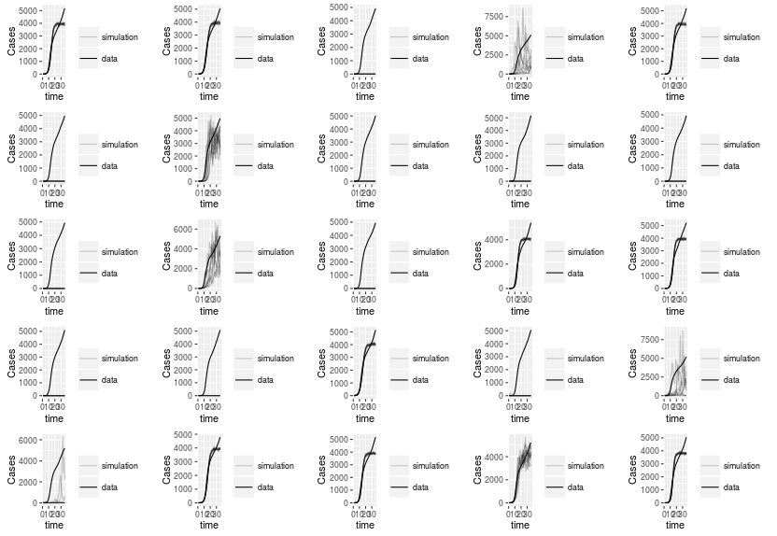**Cumulative Traj Match: 36 points** (None diverged from data)

Again, 10 of 25 matches fail. Still have varying levels of success with traj matches that don't fail.

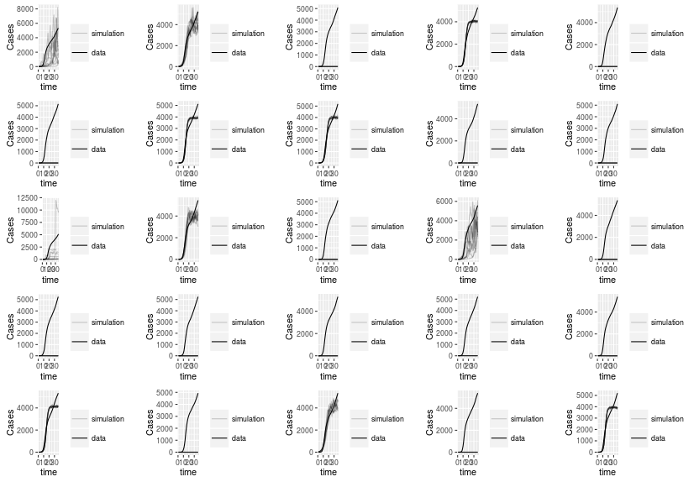**Cumulative Traj Match: 37 points** (None diverged from data)

Now 14 matches fail.

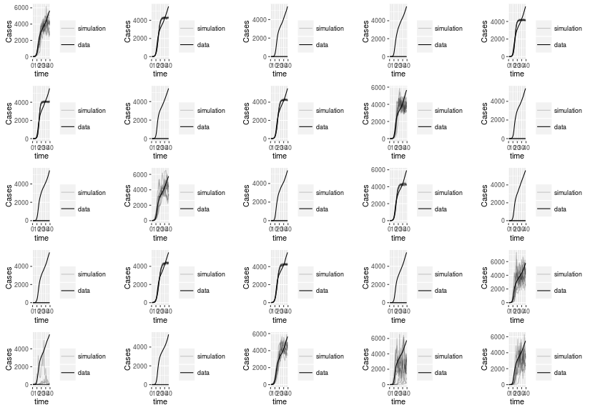**Cumulative Traj Match: 38 points** (None diverged)

With all the data, see the same general trend as the past couple analysis. (10 fails, mixed results of those that don't fail).

Raw data seems to be better than cumulative.